**ORGANIZATION STRUCTURE**

We can attach two meanings to the term organization

1. An institutional/functional group eg a business, hospital, school etc
2. A formalized intentional structure of roles and positions. People working in an organization must carry out certain roles. These roles should intentionally be designed to ensure that required activities are done and that these activities fit together so that people can work smoothly and efficiently.

**What is an Organizational Chart?**

The definition of an organization chart or "org chart" is a diagram that displays a reporting or relationship hierarchy. The most frequent application of an org chart is to show the structure of a business, government, or other organization. Org charts have a variety of uses, and can be structured in many different ways. They might be used as a management tool e.g. for planning purposes, or as a personnel directory.

**Features**

* They are visual representations of an organization’s structure
* These charts clearly outline the hierarchy within an organization and indicate the relationships shared among each individual employee.
* These insights help employees understand who to report to and ensure that managers are properly delegating tasks and responsibilities amongst their team.
* Organizations that utilize charts also experience many more benefits that drive efficiency and streamline communication.

## **IMPORTANCE OF ORGANIZATIONAL CHARTS**

Organizational charts are useful in a number of ways. Here are a few of the ways your company or group can benefit from an org chart.

* Show work responsibilities and reporting relationships.
* Allow leadership to more effectively manage growth or change.
* Allow employees to better understand how their work fits into the organization's overall scheme.
* Improve lines of communication.
* Create a visual employee directory.
* Present other types of information, such as business entity structures and data hierarchies.
* **Performs administrative tasks**

Organizational charts empower executives and managers to complete administrative tasks and view organizational needs at a glance from a single page. Such users can view open positions, pending applications for those positions, complete performance appraisals, file corrective actions and more. By performing these actions directly from the organizational chart, executives and managers can expedite processes that usually require a lot of coordination and back-and-forth communication.

* **Clearly identify the Chain of command**

In organizations with hundreds of employees, its easy to lose sight of the chain of command. Understanding the chain of command within an organization is important when determining who is the correct person to report to when certain situations arise.

* **Helps Employees Clearly Identify Team Leaders**

Organizational charts help employees clearly identify all team leaders within their organization. Providing this information to all the employees minimizes the amount of time wasted dictating who to pass on information to.

* **Allows Workflows**

Maintaining this structure electronically within the HR software can allow workflows like leave requests and position requisitions to be automatically routed to the appropriate managers and executives for approval.

**Understand workforce’s needs**

Organizational charts make it easy to analyze workforce needs by allowing executives to see their workforce from a bird’s-eye view. By taking a big step back, executives can see which departments require additional employees and which departments are overstaffed. This knowledge makes it easier to balance out teams and ensure managers have enough workers to reach their goals and objectives.

Organizations charts are incredibly useful especially if used with a position **control**-**based** **software** to help executives organize their workforce.

Employees also experience benefits from org charts by **identifying** **the** **proper** **chain** **of** **command** within their organization and communicating with their appropriate colleagues.

Implementing org chart within your organization will help **optimize your organization** when it comes to **efficiency and communication.**

**ORGANIZING AS A PROCESS**

The process of organizing in a formal organization involves.

1. The identification of activities to be carried out.
2. Classification and grouping of activities of a similar nature into, for example departments.
3. The assignments of authority and responsibility to individuals to manage these departments or groups.
4. The provision for co-ordination to ensure that organizational goals are achieved.

##### **Principles of organisation**

Lyndal Urwick consolidated Fayol’s ideas and, to an extent, synthesised them with the approach of scientific management. He put forward ten principles of organisation, as follows:

##### **Principle of objective**

Every organisation and every part of the organisation must be an expression of the **purpose** of the undertaking concerned, or it is meaningless and therefore redundant.

##### **Principle of authority**

In every organised group the supreme authority must lie somewhere and there should be a clear line of authority from the supreme authority to every individual in the group (this is also known as the "scalar principle").

##### **Principle of responsibility**

The responsibility of the superior for the acts of his subordinates is absolute.

##### **Principle of correspondence**

In every position, responsibility and authority should correspond.

##### **Principle of continuity**

The organisation is a continuous process over time, and specific provision should be made for this continuity of process in every undertaking.

##### **Principle of specialisation**

The activities of every member of any organised group should be confined, as far as possible, to the performance of a single function.

##### **Principle of definition**

The content of each position, including the duties involved, the authority and responsibility contemplated, and the relationships with other positions, should be clearly defined in writing and published to all concerned.

##### **Span of control**

No person should supervise more than five, or at the most six, direct subordinates whose work interlocks.

##### **Principle of balance**

It is essential that the various units of an undertaking should be kept in balance with the purpose of the organisation (a cryptic phrase, but, for example, in the health service there is constant criticism that the proportion of administrative staff to front line nursing staff is "out of balance").

##### **Unity of command**

Each member of an organisation should have only one boss, with no conflicting lines of command.

**THE ORGNIZATION STRUCTURE**

Organization structure refers to the established pattern of relationship among various components or parts of an organization. Broadly it can be defined as that mechanism that serves to co-ordinate and control the activities of organizational members.

**Characteristics of a Good/Sound Organizational Structure**

1. It should lead to effectiveness and efficiency i.e. it should lead to accomplishment of purpose through economic utilization of resources.
2. Clear lines of authority to avoid conflicts and inefficiency.
3. Adequate delegation of authority should be facilitated to enhance decision making, decision implementation and motivation.
4. Minimum managerial levels to shorten chain of command.
5. Unity of direction. Should facilitate unity of direction to avoid confusion and draw conflicts.
6. Application of ultimate responsibility. The higher level manager is not absolved from responsibility through delegation.
7. Appropriate span of control. A good structure should provide for a good span of control.
8. Simple to avoid confusion and ambiguity.
9. Flexible. Structure should be flexible to care for future considerations.
10. Consideration for top management. Should provide due consideration for top management and provide good relationship with other organizations.
11. Balance structures. Should have balance between horizontal units and levels and proper proportion between decentralization of authority.
12. Control. A good structure should provide for actual measurement of actual performance and its comparison with the set standards so that corrective action can be taken.

**THE ELEMENTS OF ORGANIZATION STRUCTURE**

1. Division of work/work specialization
2. Departmentation
3. Pattern of authority
4. Span of control

**1. Division of Work/Work Specialization**

Division of work unifies the division of labor. The division of labor normally leads to specialization. Greater specialization leads to greater productivity. Specialization may be of high or lower degree.

1. High Degree of specialization. Where this exists, individuals focus on one or a few tasks e.g. in an automobile assembly workers are assigned a few specific tasks.
2. Low Degree of specialization. An individual will perform different tasks in the organization e.g. A manager, who hires and fires, keeps financial records, contacts suppliers, travels to sell organizational products etc.

**2 Departmentation**

This refers to the grouping of similar activities together. This grouping should be done in order to enhance co-ordination and control of organization activities.

**3. Pattern of Authority**

Authority refers to some of the rights and powers to be exercised by members of organization. Authority can be centralized or decentralized and can be delegated from superior to subordinate.

**4. Span of Control**

This refers to the No of subordinates reporting to a single superior/supervisor. An organization may have.

1. Narrow span of control where **few** people report to a supervisor
2. Wide span of control where **many** people report to a supervisor

**THE SPAN OF CONTROL**

The span of control is a statement or expression or a limitation of the No of subordinates of activities that a manager can manage properly.

**Factors Determining the Span of Control**

They include the following:

1. **Nature of the work**. If the work to be performed by subordinate is of a complex nature, then the fewer should be the subordinates under a single superior because in dealing with one subordinate a manager must devote more time. If the work is of a routine nature or highly stratified the more should be the no of subordinates.
2. **Capacity and experience of the manager**. The span of control will also depend on knowledge, energy, personality, interest, attitude, experience etc of the manager. The more of these attributes the manager has the higher the number of subordinates who can be effectively supervised and vice versa. Also important is the manager’s ability to reduce the frequency and time impact of the superior/subordinate relationships. The less the frequency the more the no of subordinates to be supervised and vice versa.
3. **The efficiency of the systems employed**. The systems and control procedures also affect the span of control. If they are efficient and improved, the span of control can be wide and vice versa.
4. **Use of personal assistants**. Personal assistants can deal with the day to day problems without recourse to the superior. Cutting short contacts with subordinates enables the supervisors to widen his/her span of control. Where a personal assistant doesn’t exist the span tends to be narrow.
5. **Subordinates training**. The better the training the higher the skills they possess, the wider will be the span of control. Untrained subordinates will need close control and supervision and this narrows the span of control.
6. **The extent of delegation of authority**. If the manager delegates clear and sufficient authority to the subordinates the span of control can be wide. The subordinates will also require less of the manager’s time. Where authority is centralized at the top level the span of control tends to be narrow.
7. **The use of standing plans e.g. rules and procedures**. Their use relieves the top executives of the burden of making decisions all the time as they serve to guide the subordinates. They can be used to solve recurrent problems therefore widening the span of control. Where they are not used, the span of control tends to be narrow.
8. **Geographical Dispersion**. Where operations are geographically dispersed, the span of control tends to be narrow because territorial separations make personal contacts difficult. Where activities are concentrated in one area the span of control can be wider.
9. **The level of management**. The span of control at lower levels tends to be wider than at higher levels. High level managers are involved in other activities e.g planning besides supervision. At lower levels work tends to be routine allowing for a wider span of control.
10. **The personal preferences of the manager**. Higher level managers are able to dictate how many individuals will report to them. It is prescribed for the lower level of management.
11. **Environmental factors**. If an organization operates in unstable dynamic environments, a narrow span of control may prove more effective but if the environment is static with relatively stable conditions a wide span can be applied.

**NARROW SPAN OF CONTROL**

This creates a tall organization structure with many levels of management because only a few subordinates report to singlesupervisor.

**Advantages**

1. It creates personal contact between managers and subordinates.
2. It offers/facilitates tight control/close supervision.
3. A manager has more time to plan for the future as he or she only deals with a few subordinates.
4. Managerial efficiency is improved by having fewer contacts and activities.
5. A narrow span develops good human relations in the organization due to direct contacts.

**Disadvantages**

1. It creates many levels of management which are expensive and time consuming.
2. The administration overhead costs are high
3. Many levels work against effective communication
4. Co-ordination of activities is also difficult

**WIDE SPAN OF CONTROL**

A wide span of management creates a flat organization structure since a large no of subordinates report to a single supervisor.

**Advantages**

1. It is economical. Reduced levels reduce cost through fewer managers.
2. It offers more opportunities for subordinate’s development by thinking and deciding for themselves.
3. Due to a direct contact between managers and subordinates communication and coordination is improved.

**Disadvantages**

1. Managers will be unable to exercise effective control/supervision and so the quality of performance will go down.

2. Better trained and thus costlier personnel are required as they have to act independently most of the time.

3. Employees may feel detached from the point of control and therefore unimportant to the organization. The best span of control will vary depending upon the particular circumstances.

**AUTHORITY RELATIONSHIP**

**Delegation of Authority**

Delegation is conferring or granting of authority from superior to subordinate to accomplish particular assignment or to entrust part of the work. Through delegation or transfer of authority a manager multiplies himself and gets result through others.

According to “Allan” delegation is the entrustment of a part of the work or responsibility and authority to another and the creation of accountability for performance.

**ELEMENTS OF DELEGATION**

* Assignment of responsibilities
* Grant of authority
* Creation of accountability
* **Assignment of Responsibility**

Responsibility is the work assigned to a position. A manager assigns certain functions, work or duties to the subordinates. Responsibility therefore arises from the supervisor/subordinates relationship. It is the creation of an obligation to perform the assigned duties.

* **Grant of Authority**

Authority is the sum of powers and rights entrusted to make possible the performance of the work delegated. It is the right to perform certain work or duties. It is therefore derived from responsibilities. **It is the power to order or command.**

* **Creation of Accountability**

This is the obligation to carry out responsibility and exercise authority in terms of performance standards established. It is the obligation of individual workers **to tender an account of the fulfillment of her or his responsibility to the boss.** Accountability is derived from authority. **Authorities flow downwards whereas accountability flows upward**. In effective delegation all these 3 attributes are equally interrelated and interdependent i.e. once a manager has assigned responsibilities to his subordinate and has delegated authority to him accountability has been exacted from the subordinate.

**Reasons for Delegation**

1. **Lack of time or energy**. Human beings have limited time and energy. They must therefore divide the work load and share the duties and responsibilities/tasks.
2. **Complex and intricate techniques**. This will mean specialists are needed. The manager will therefore delegate the work of deliberation and formulation of plans to specialist.
3. **Geographical dispersion/Diversification**. This means that there will be a network of branches and multiple plants spread over a wide area. Big businesses are compelled to divisionalise their organization. Delegation and centralization offers the best solution to effectively manage diversified and dispersed businesses.
4. **Method of motivation**. Delegation builds a tendency towards greater interest and emphasize on the part of the subordinate. Since they have greater participation in decision making they respond positively to challenge and responsibility that comes with delegation.
5. **Management Development**. It is used as a form of training for future managers. This helps in avoiding organizational gaps and achieving continuity in management; this leads to organizational stability.

**Obstacles/Barriers to Delegation**

a) **From management point of view**. They include

1. **Perfectionism**. An executive may feel he can do the jobs himself. Sometimes they feel that the initial effort of subordinates is dummy (fake, false) and inadequate.
2. **Autocratic attitude**. A manager may be a power worshipper. Such people believe in the least delegation of authority and interfere with the authority of subordinates.
3. **Poor direction.** Sometime managers are impatient to get results. They may misinterpret the instruction they give extending the same to subordinate.
4. **Confidence**. Manager may lack confidence on the subordinates for work they have not done.
5. **Controls**. Managers may fear to delegate because they fear **serious damages** may occur before they realize it.
6. **Temperamental aversion to risk**. There are people who naturally fear to take risks. Such people are reluctant to delegate.
7. **Competition**. Managers fear that if subordinate learn too much they may become rivals.

**b) Subordinate point of view**

1. **Easier to ask**. Subordinates like asking for solutions, they don’t like making decisions.
2. **Fear of criticism**. Subordinates fear criticism from superiors. This discourages initiative, causes resentment and destroys subordinate’s self-confidence.
3. **Lack of information/resources**. If subordinates lack either of the two it becomes very difficult to perform the job as required.
4. **Overwork**. Subordinates fear additional work (tasks) especially when they are not accompanied by a relaxation on other previous duties.
5. **Lack of self-confidence and fear of failure**. This will mean the subordinate will not want a new responsibility.
6. **Lack of positive incentives**. Subordinates need systems of reward for acceptance and successful completion of delegated task e.g. pay increase, promotion, personal recognition, approval by the boss etc.

**EFFECTIVE DELEGATION**

1. **Authority and responsibility must be equal**. To avoid misuse, excessive authority should not be granted. To avoid non acceptability, insufficient authority should not be conferred.
2. **Responsibility cannot be delegated**. Delegating authority does not absolve a manager from responsibility. The manager must continue to guide, direct and control the subordinate.
3. **Dual subordination should be avoided**. The principle of unity of command should be upheld where a subordinate should receive instruction and be answerable to one supervisor only.
4. **Duties should not overlap**. This develops clashes. Joint workers will find it very hard to operate.
5. **Avoid organizational gaps**. All positions should be filled. Gaps cause frustrations when people find out they have no person to depend on to get work performed.
6. **Apply managements by exception**. The manager should delegate as much routine work as possible and leave for him/herself only broad general problems and exceptions to routine. However, a manager must develop procedures to guide the subordinates.
7. **Training and Development**. Effective delegation can be achieved by developing subordinates through planned experience and training them to accept delegation.
8. **Adequate controls**. Managers must set up adequate controls which will act as selective check points where measuring will be made to see if any corrective action is necessary. This will make delegation more effective.
9. **Clear goals** – There should be clear and definite goals so that the subordinates know why their work is important and necessary.
10. **Motivation/stimulation**. Subordinates should be motivated by being encouraged so that they can effectively carry out delegated tasks.

**IMPORTANCE OF DELEGATION**

1. Delegation is the **key to organization**. Without delegation there will be no organization, only one man operation would exist.
2. It gives time to top management to **plan and control** the activities of subordinates.
3. It **helps the subordinates to show initiative** and develop themselves on the job.
4. It is an effective means of **training**.
5. It **reduces organizational stress** as more is accomplished with less worry and tension and less risk in health.
6. It creates a reservoir for executive **skill and talent** which leads to organization stability.
7. **Increase productivity** in the organization.
8. Facilitates **easier management** for big organization.

**CENTRALISATION**

It refers to systematic efforts to **delegate to the lowest levels all authority** except that which can only be exercised at the central point. It is therefore delegation of authority from a higher level to a lower level. Everything that goes to increase the importance of the subordinate’s role is decentralization and everything that goes to reduced subordinates’ role is centralization.

**Delegation vs decentralization**

|  |  |
| --- | --- |
| **Delegation V/S** | **Decentralization** |
| 1. Is a process. | 1. End result of planned delegation. |
| 2. Is between supervisor and subordinate. | 2. between top and lower levels of the organization. |
| 3. A must for organizations/management. | 3. This is optional and appears on the scene when the organization has grown and is large and complex. |
| 4. Supervisor exercises direct supervision and control over subordinate. | 4. Top management exercises broad and minimal control. |

**Indicators of Decentralization**

Certain authorities or powers can be used as standards in determining the degree of decentralization. They include.

1. Hiring and firing of employees
2. Approval of pay increases
3. Promotion of officers
4. Purchase and sale of capital equipment
5. Approval of price quotations
6. Acceptance of sales orders
7. Approval of travel expenses etc.

**Factors Determining Decentralization**

1. **Costliness of the decision**. For crucial or strategic decisions involving a higher cost of mistake due to greater risk and uncertainty, no decentralization is feasible. Top management must reserve decision and actions which may have long term consequence for the organization.
2. **Need for uniformity of policy**. Only centralized authority can ensure uniformity of policies for all departments or for all customers e.g. regarding quality service, credit, prices etc. This will ensure easier comparison of relative efficiency of the department and can keep down costs.
3. **Organization size**. The right kind of decentralization is inevitable in large enterprises with a long chain of command and many managers at each level.
4. **Firm’s History and management philosophy**. If a company has grown up from a small group of persons there is tendency to centralize.
5. **Capable managers**. Decentralization demands many managers, there should be sufficient management development programme necessary to provide for the many managers.
6. **Control techniques**. Decentralization will be more effective if control techniques are good. There should be control over all subordinates.
7. **Dynamic conditions**. If the conditions of uncertainty prevail i.e. when technology and markets are in a constant state of change the need for decentralization becomes clear. In a static environment, centralization will work.

**Benefit/Advantages of Decentralization**

1. **It is a relief to top management**. Top management needs more time for planning therefore most of operational work is left to subordinates.
2. **Diversification**. Decentralization must accompany divisionalization if a company wants the most effective diversification plans. This diversity of business is a compelling force for decentralization.
3. **Emphasis on products**. Decentralization has a great impact on product innovation and the growth of its market share. The customers are concerned with prices, quality, delivery of services, etc. These demands are easily satisfied through decentralization.
4. **Management development**. Decentralization offers ample scope for the development of management. Under decentralization managers can develop initiative and enjoy freedom to try out innovations in methods and techniques.
5. **Higher motivation**. This is achieved through greater participation, communication and delegation of authority.

**Drawbacks/Disadvantages**

1. **Lack of co-coordination**. Due to the wide dispersal of authority, the problem of co-coordination is created.
2. **For specialized services** e.g. accounting, personnel, research, statistics etc., decentralization is unwarranted.
3. There are **certain areas of control and responsibilities** which demand centralization e.g policy and objective formulation, approval of corporate plans and budgets, capital investment plans etc.
4. In crisis or emergencies decentralization will not work very well.

**Guidelines to Decentralisation**

1. There should be appropriate decentralization and centralization in all managerial functions at the top i.e. planning, co-coordination, control, motivation etc.
2. Capable managers should be developed who can understand the operations of autonomous business units i.e. who can be delegated authority and responsibility.
3. Develop an effective communication system.
4. Adequate control systems at all levels.
5. The created business units must operate as independent profit centres.

**ORGANIZATION DESIGN**

Organizational structure provides the **basic building blocks** for the overall design of an organization. Managers can combine various structures to select an organizational design that will enhance coordination and accomplishment of goals. Organization design therefore refers to the **basic structures** of an organization that facilitate coordination and control of its activities.

There are 4 organization design options

1. Functional design
2. Divisional design
3. Hybrid design
4. Matrix design

**1. Function design**

Here employees are grouped together according to similarity of skills or activities e.g. sales, personnel and marketing department, Accounts and finance etc. It is the most common type of organizational design. It is normally used from small to medium size organizations with a few products and where there is a need for a high level of work specialization.

**Advantages**

1. It leads to efficient utilization of resources. Economies of scale are possible when common tasks are grouped together.
2. Leads to in-depth skill development. More intensive training of members is possible within the department due to similarities of knowledge.
3. Clear career paths. Employees have a clear understanding of job requirements and paths that can lead to promotions.
4. Strategic decisions are made at the top. Centralized decision structure facilitates unity of direction as the management provides co-ordination and control of organization.

**Disadvantages**

1. Delays in work. Centralized decision making slows down work in organizations.
2. There is little innovation. Members of dept become less innovative because of the focus on departmental goals rather than overall goals of the organization.
3. Problem of poor co-ordination across departments. Members of a department may feel isolated or even hostile to those in other departments.

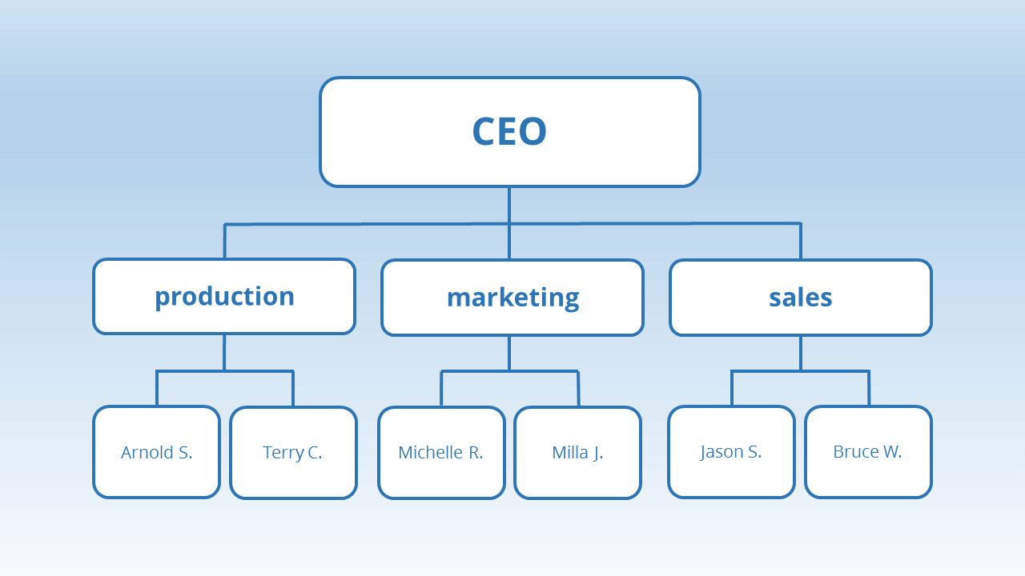

***Fig. 1: Showing a Functional Organizational Chart***

**2.Divisional design**

This option should be taken when the organization growth is accompanied by **expanded product lines** and more **customer or geographic expansion**. They include:

**a) Product division**

Each unit is responsible for a single product or a group of related products. The division of the products is created when a product/groups of products have a common process of production or marketing method that are different from those of the other products in the company eg Unilever co.

**b) Customer Division**

This is created when the organization sells products to diverse groups of customers. A single group may have diverse customers or manager may believe that there are groups of customers with special needs to be met, by instituting customer division a close relationship can be established between a division and unit customers eg KPLC

**c) Geographical /Territorial Division**

Large organizations usually develop divisions based on geographical or territorial areas. Geographical division is advantageous when it is necessary to locate facilities close to the customers who may have differences in tastes and needs e.g. coca-cola.

**Advantages of division design**

1. Easy adaption to environment
2. Higher customer satisfaction as more attention is given to customers’ needs.
3. Higher task co-ordination, more communication and team work across the dept is possible.
4. Clear performance responsibility. Each division can be made a profit centre therefore permitting assignments on specific objectives to be met.
5. General management training. Divisional managers learn how to co-ordinate and control activities among several departments. They can be shifted to different divisions to run the organization, various product lines and to improve their general management skills.

**Limitations**

1. Inefficiency. There is an inefficient use of resources. There is duplication of resources across divisions.
2. There is a focus on divisional objectives. This makes the coordination across the divisions difficult.
3. Loss of control. Top management may lose control of its division. It is difficult to impose rules and regulations.

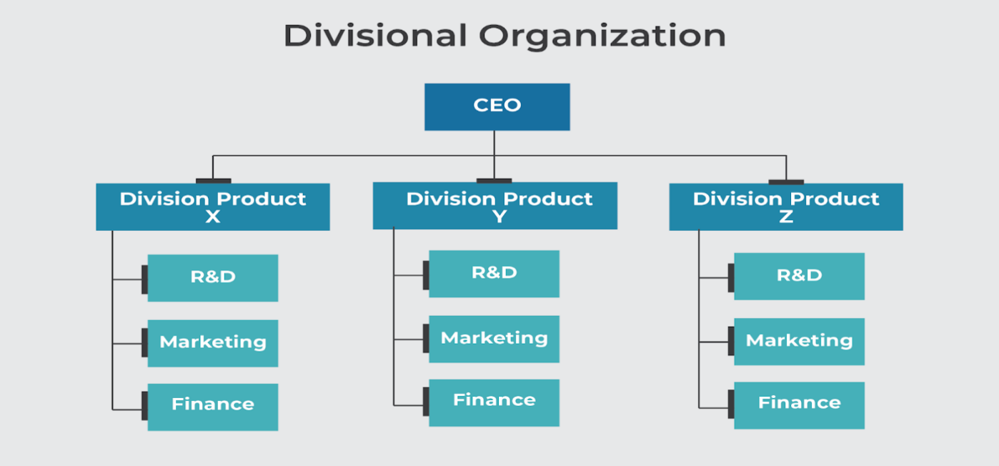

***Fig 2: Showing Divisional Organizational Chart***

1. **Hybrid Design**

Has both **functional** departments and **divisional** units. The functional departments are centralized and located at the corporate headquarters e.g. A company may have the human resources department located at the headquarters. This department will service other departments and branches by carrying out recruitments, training and development and maintaining employee’s records. The divisional units will be responsible for the other functions that are not centralized.

**Advantages of Hybrid design**

1. Simultaneous coordination across and within division can be achieved. The centralized functions enable co-ordination across division by establishing activities or programs that direct each division or branch.
2. It provides autonomies for divisional branches to modify their objectives based on their unique situations/circumstances. However, the centralized functions serve to generate the awareness of the overall corporate goals among the divisions.
3. Adaptability and efficiency. The division or branch units are able to adapt to the opportunities and constraints of the environments.

**Weaknesses/Disadvantages**

1. It leads to a **slow response in exceptional situations** when a division is confronted with a situation that is unique, solution must be obtained from the headquarters. This can result in delays and inefficiencies as the division or branch could be better equipped to handle the problem.
2. **Conflicts** might arise between the headquarters and the divisions. Functional depts. at the headquarters often do not have supervisory authority over the divisions yet they often try to influence the divisional activities. This leads to conflicts between the two.
3. The **administrative** **overheads** are high. The functional depts. at the headquarters have a tendency to grow as staff are added to assist the control of the branches or divisions.

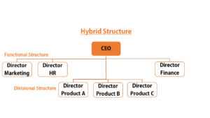

***Fig 3: Showing a Hybrid Organizational Chart***

**4. Matrix Design**

* Most organizations have elements of **functional, divisional, or hybrid** design.
* The result is a system characterized by employees in each department being **supervised by two bosses** or a system of **dual authority**.
* One boss is a **functional** manager while the other is a **divisional** manager.
* The functional and divisional managers have **equal authority within division**.
* It is most suitable when environmental pressures exist for dual focus e.g. competition regulatory requirements or consumer demand may require the organization to provide not only multiple and innovative products but also products of high technical quality.

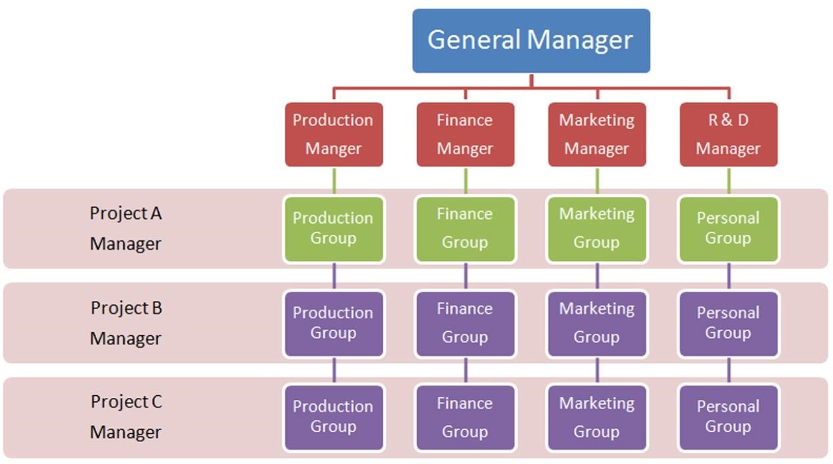

***Fig 4: Showing Matrix Organization Chart***

**Advantages**

1. It allows demand from the environment to be met simultaneously e.g. multiple products innovation etc.
2. It encourages resource efficiency.
3. Aids top mgt in planning the day to day operational activities or decisions are delegated to the functional division managers.

**Disadvantages**

1. It may create confusion. The assignment of two supervisors to one subordinate may lead to confusion/conflict.
2. It may create power struggle between the divisional and functional managers.
3. Time consuming. A large amount of time is required to make frequent meetings necessary to integrate the activities of both functional and divisional managers.
4. This design sometimes leads to delays in implementation of activities or decisions.

**COMMITTEES**

A committee is a group of people who meet by plan to discuss and to make a decision on a particular subject.

**Reasons for widespread use of committees (Advantages/importance**)

1. Group decision making. Better decisions will be reached through group deliberations and judgments. Personal bias and prejudice do not arise.
2. Creativity. Through group creativity eg brain storming, committees can produce creative ideas.
3. Co-operation. Committee encourage group co-operation and development of a sense of team spirit in the organization
4. Co-ordination. Committees promote co-ordination of various activities of an enterprise.
5. Communication. Committees enhance communication by transmitting information and ideas to the organization members.
6. Motivation. By participating in discussions in a committee a member will be highly motivated to accept or implement a decision like one of his own.
7. Consolidation of power and Authority. A committee collects and combines the authority of several individual members therefore avoiding delegating too much authority to a single person.
8. Democratization i.e. it permits greater member participation in decision making. Various interest groups are represented in a committee.
9. Avoiding action. When a manager wants to avoid action on a specific problem he may assign it to the committee and avoid the action. It blurs responsibility.
10. Stability. Committees train members to deal with various problems and make for continuity and stability of the organization as some members may stay on the committee while others retire.
11. Advising. Committees play an advising role. A manager may wish to take advice/counsel by making a decision a committee provides.

**Disadvantages of Committees**

1. Delays in decisions. This can be due to conflicting view-points of members or poor leadership. This delay destroys the utility of decisions.
2. Expensive organization. A lot of time and money is spent in convening meetings arranging discussion and reaching conclusions.
3. Least Denominator. There is a general tendency to compromise and sometimes nobody is happy with a committee decision.
4. Split accountability. It is difficult to enforce accountability against a committee
5. Psychological weakness. These include irrelevant discussions trying to flatter or impress supervisor and the tendency to jump to conclusions.
6. Self-perpetuation. Committees continue to meet long after they have ceased to serve their useful purpose.
7. Lack of secrecy. It is a form of plural executive.
8. Tyranny of the minority. Aggressive persons may dominate the committee and use their undue influence which may affect the final decision.

**Suggestions for making committee Effective**

1. Minimum membership. The number of individuals on a committee should be the minimum that will function effectively. Too many members waste time in lengthy discussions and delay decisions.
2. Well defined authority and scope. Members should know the exact scope of the subject and committee authority should be carefully spelt out.
3. Proper selection of members. Members must represent all interests intended to be served and must be able to perform well in a group. They should have the capacity for discussion and to reach group decisions.
4. Adequate preparations. The agenda should be well prepared in advance and circulated among members so that the members may have sufficient time to consider the matters at hand.
5. Proper conduct of meetings. The chairperson should be able to control the behavior of the members while in session to minimize wastages.
6. Capable/Efficient chair person. He/she should have the capacity and skill to avoid wastages by good planning and proper conduct of the meetings.
7. Cost considerations. A committee must be worth the cost.